$OX(1)$ – VERTICES - 12, EDGES - 18
METRIC DIMENSION – 2
BIGS INDEX – 6
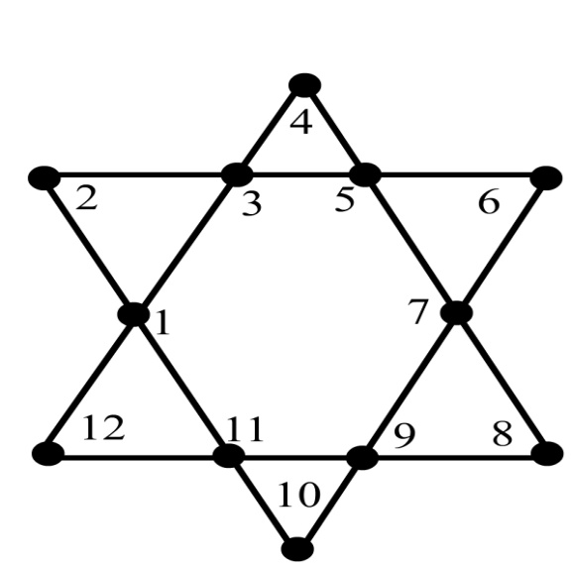

OUTPUT EXTRACTED USING BIGS ALGORITHM
- {2,6}
- {2,10}
- {4,8}
- {4,12}
- {6,10}
- {8,12}

